INTEGRATE GIT, JENKINS AND SONARQUBE

1. First Create a Dynamic Web Project
2. First go to eclipse and click on New -> Maven Project

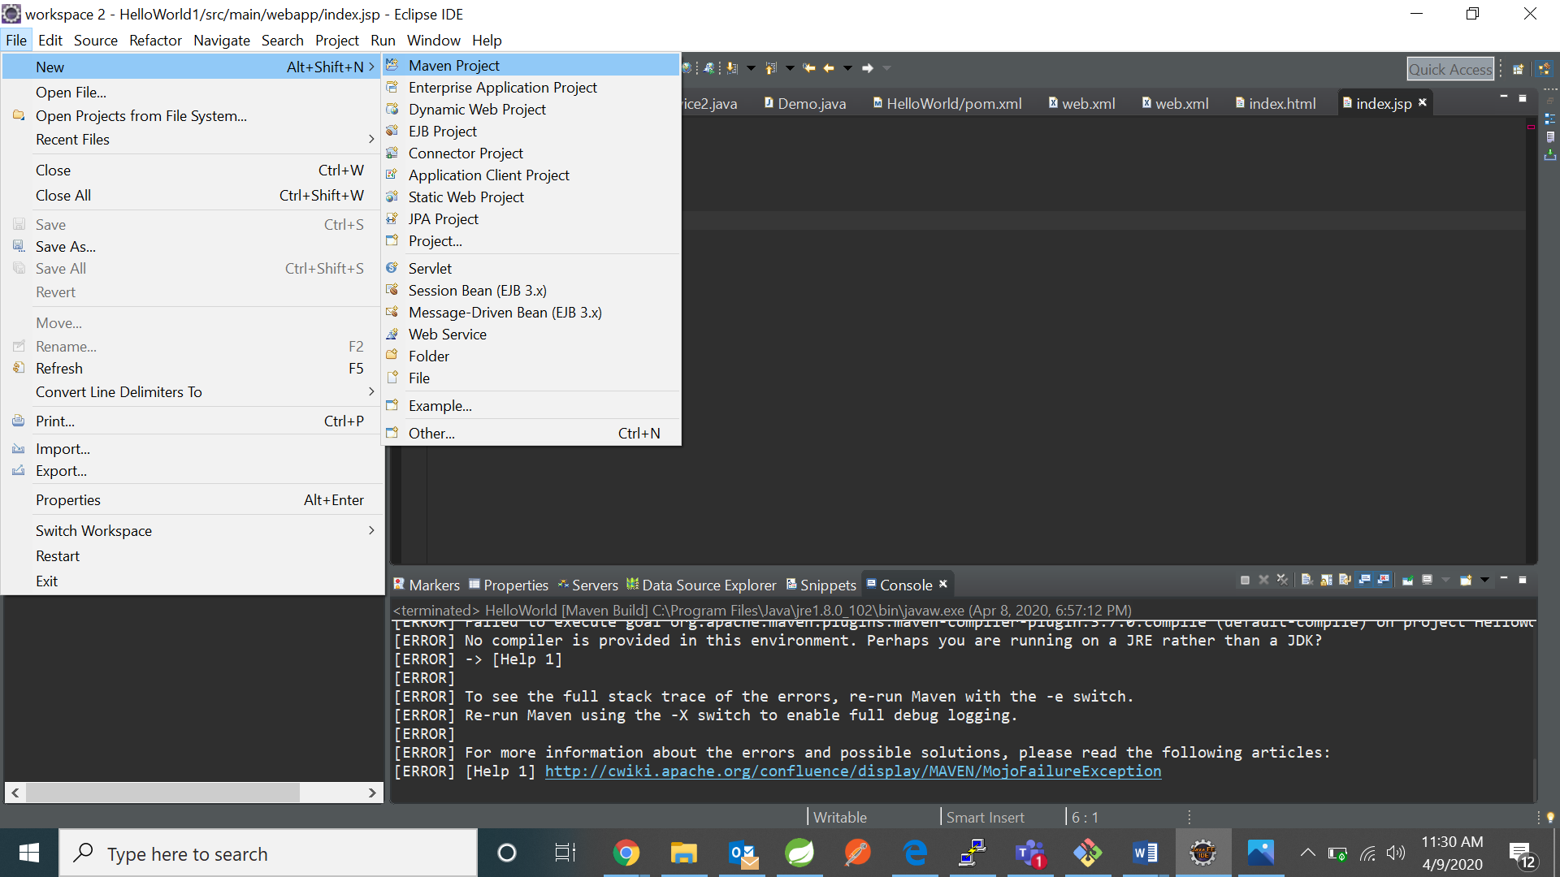

1. Click on next

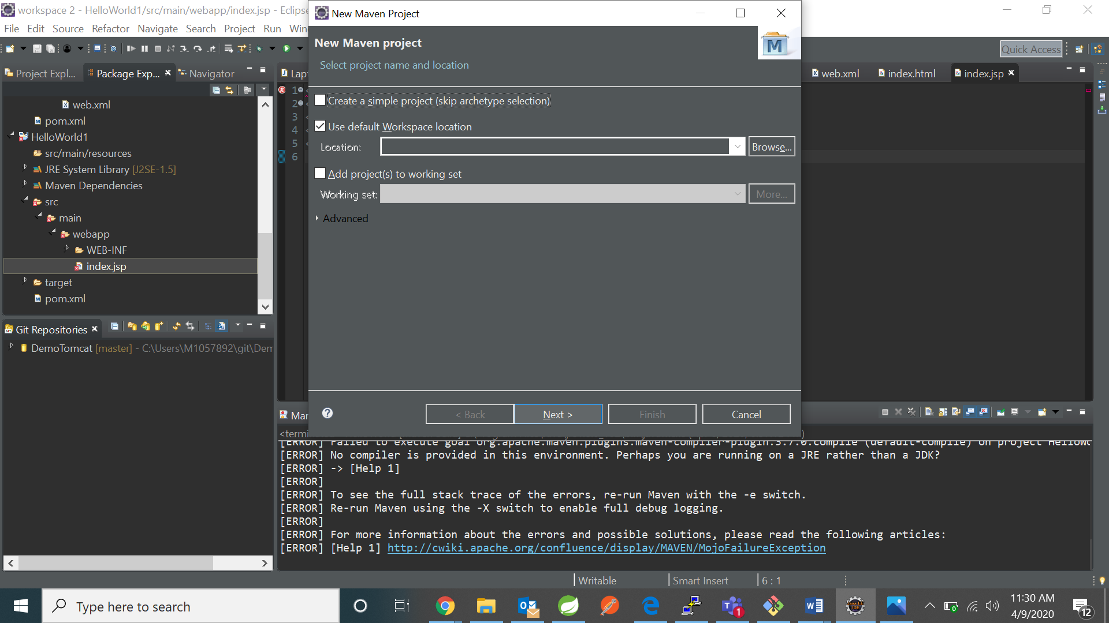

1. Click on maven –archetype-webapp and click next

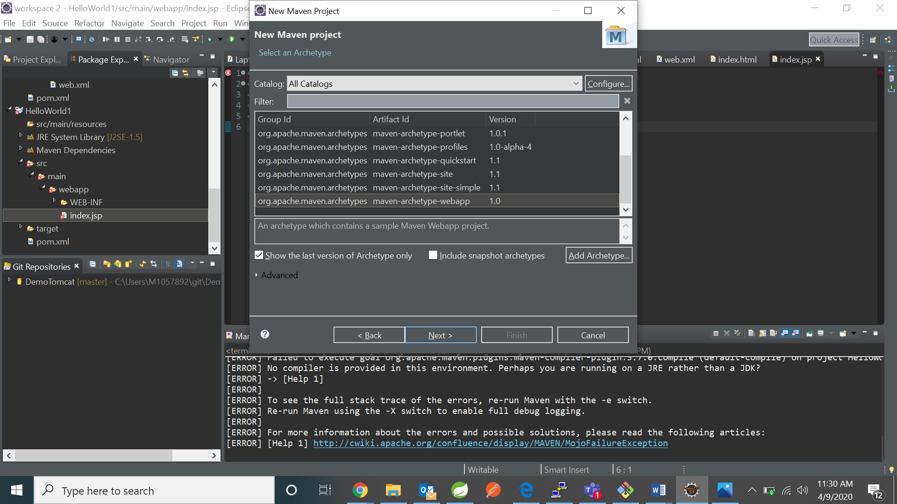

1. Fill the groupid and artifact id

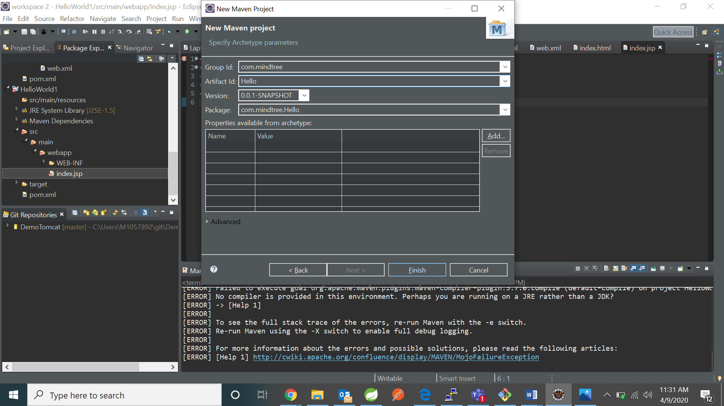

1. Push to github

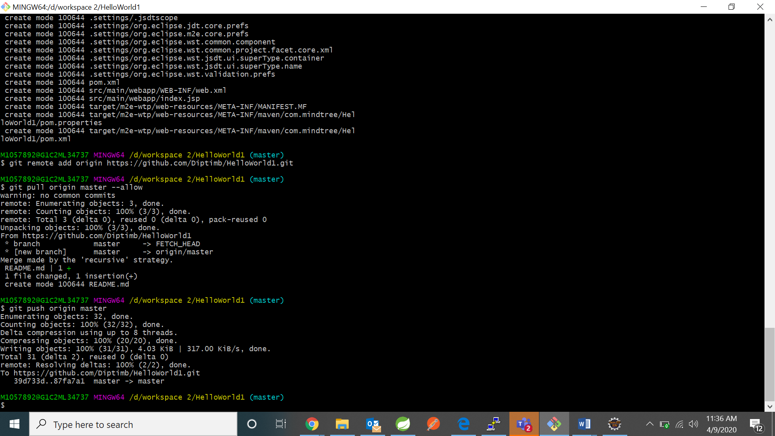

1. Now install SonarQube Scanner by going to mange Jenkins->manage plugins ->available

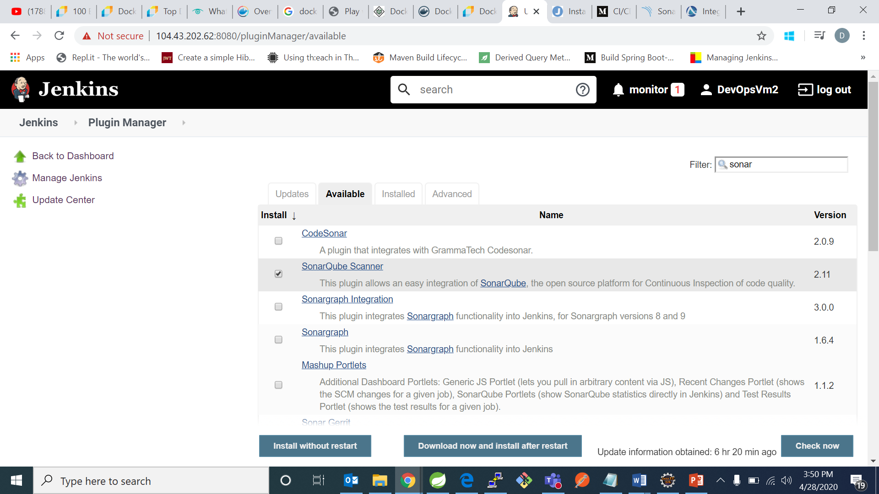

* Now we have go in Manage Jenkins > configure system and do the below configuration.

In this we have to add server URL and Credentials of sonar

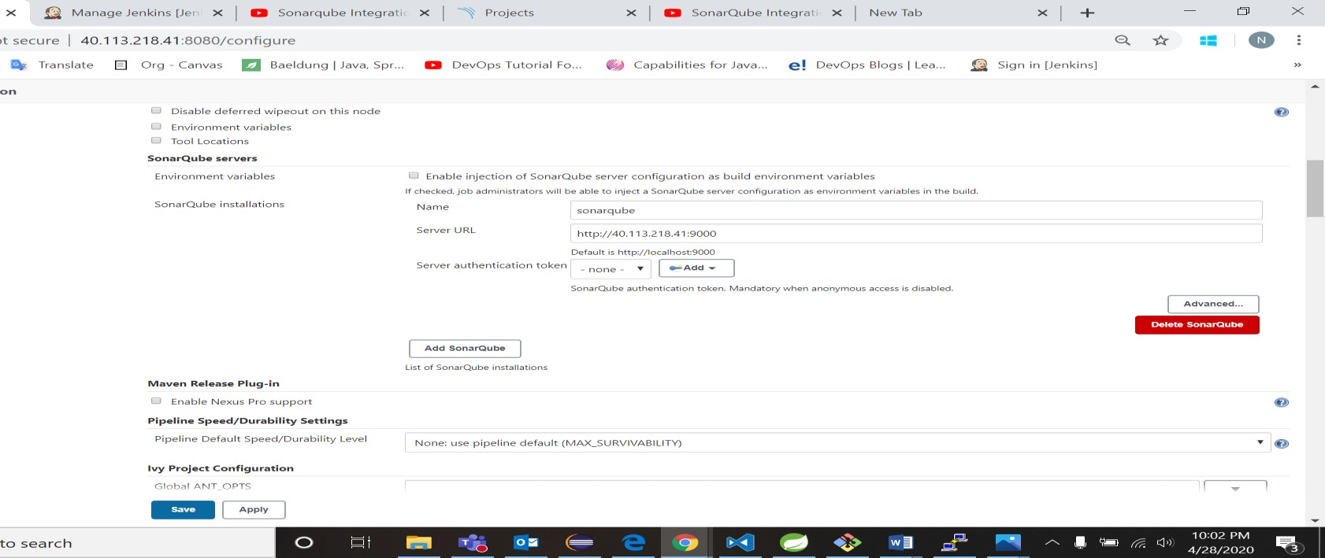

* Now we have to go to Manage Jenkins > Global tool configuration and
* Do the below configuration.

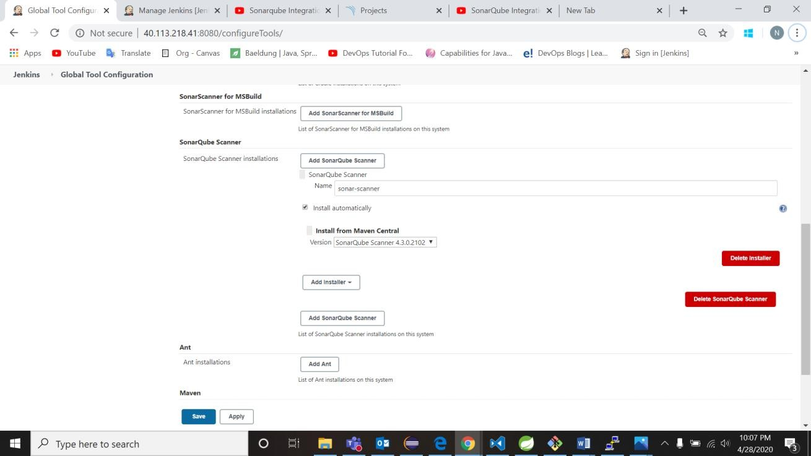

* Now go to Jenkins and create a new item in freestyle and add your github repository url: 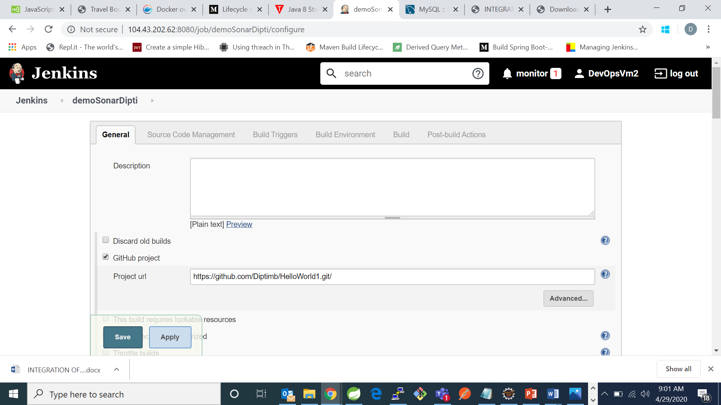
* Now go to Source Code management and add your git url:

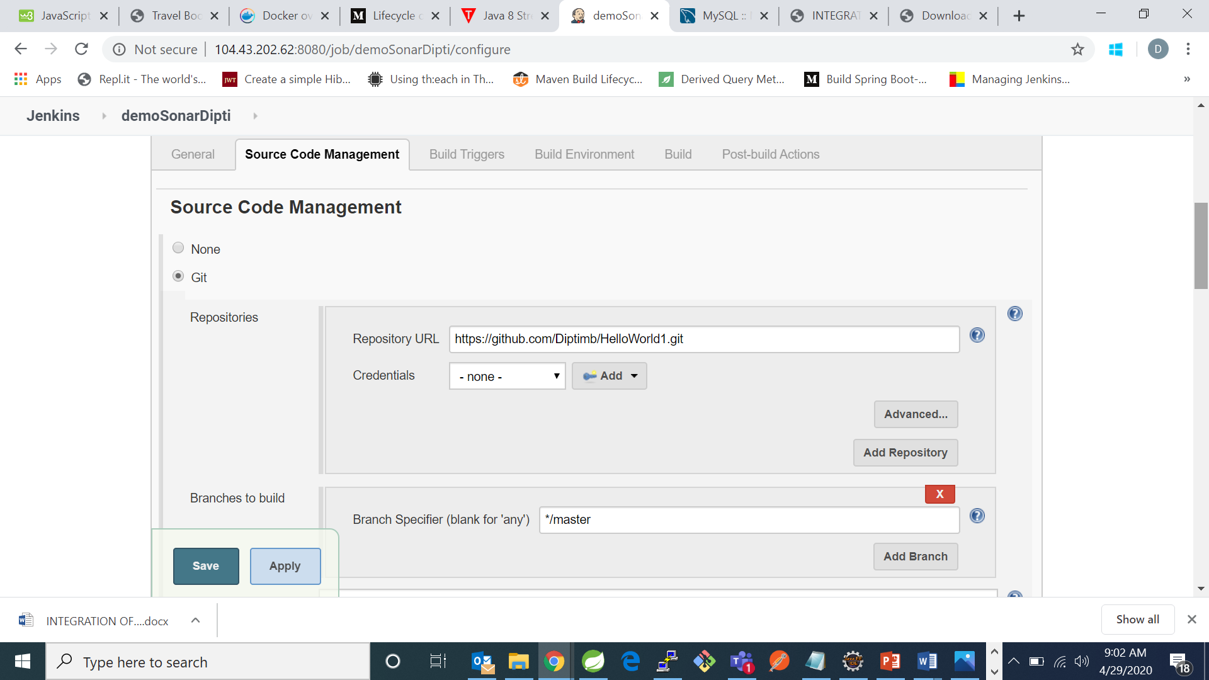

* Now go to build section and select execute SonarQube Scanner and write down the following:

# Required metadata

sonar.projectKey=java-sonar-runner-simple

sonar.projectName=Simple Java project analyzed with the SonarQube Runner

sonar.projectVersion=1.0

# Comma-separated paths to directories with sources (required)

sonar.sources=src

# Language

sonar.language=java

# Encoding of the source files

sonar.sourceEncoding=UTF-8

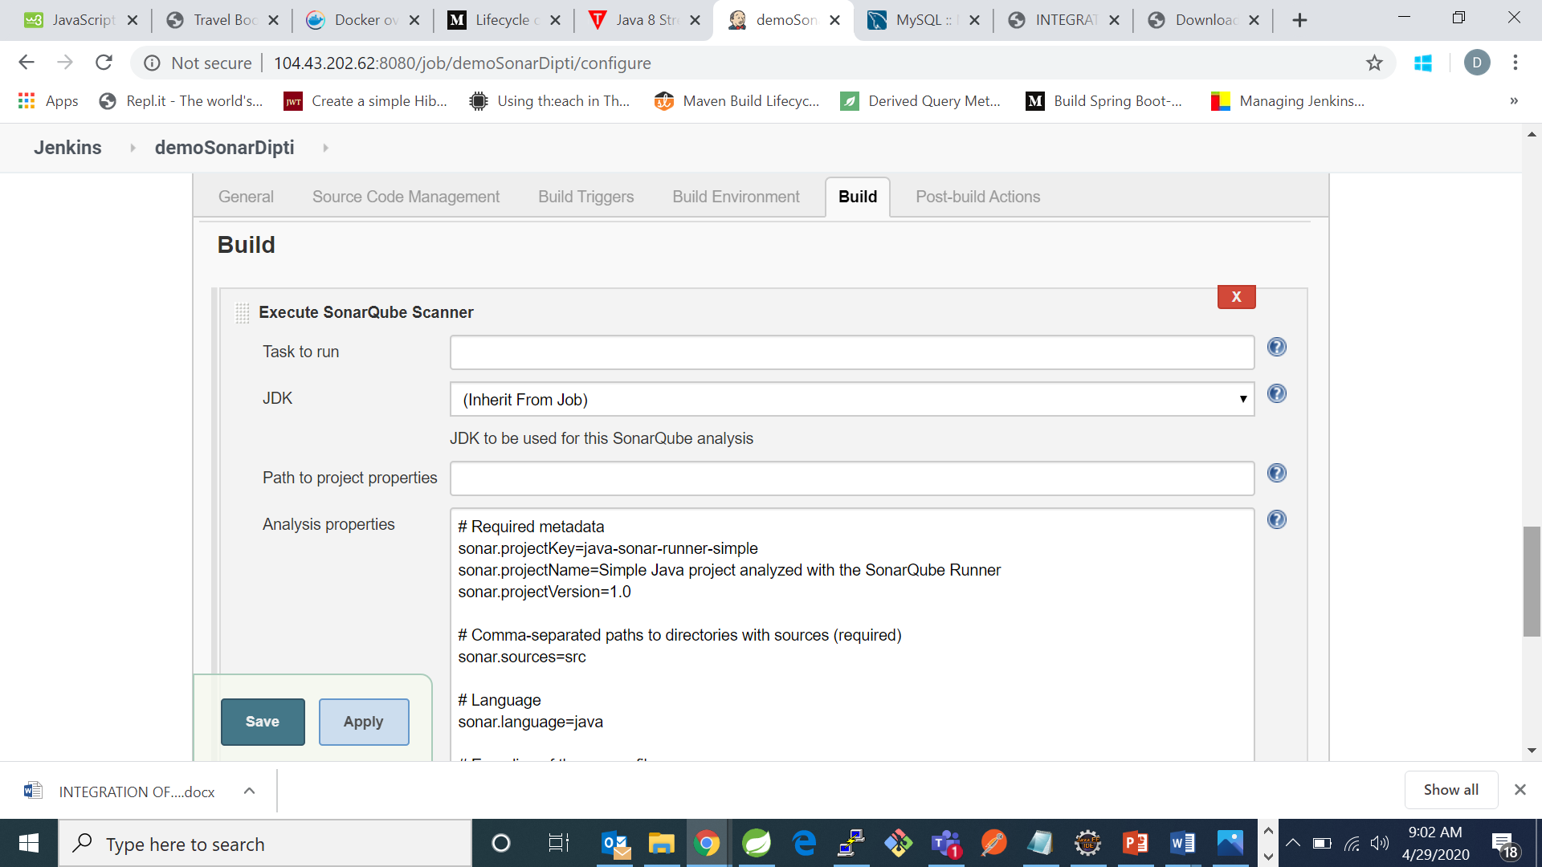

* Now click on save.
* Now build your project:

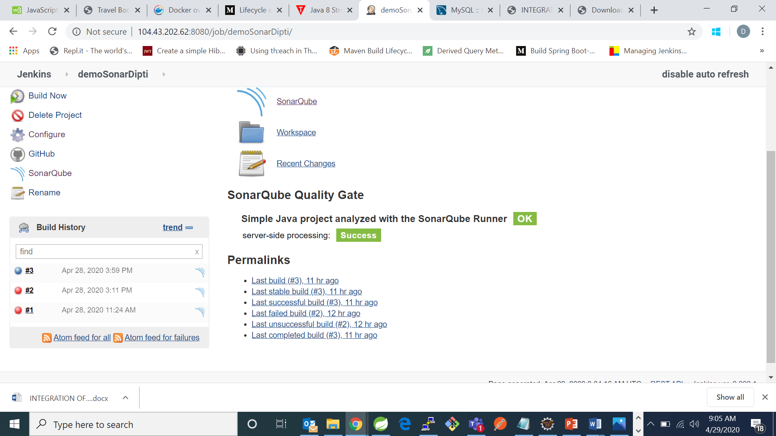

* Now go to SonarQube and see your code analysis:

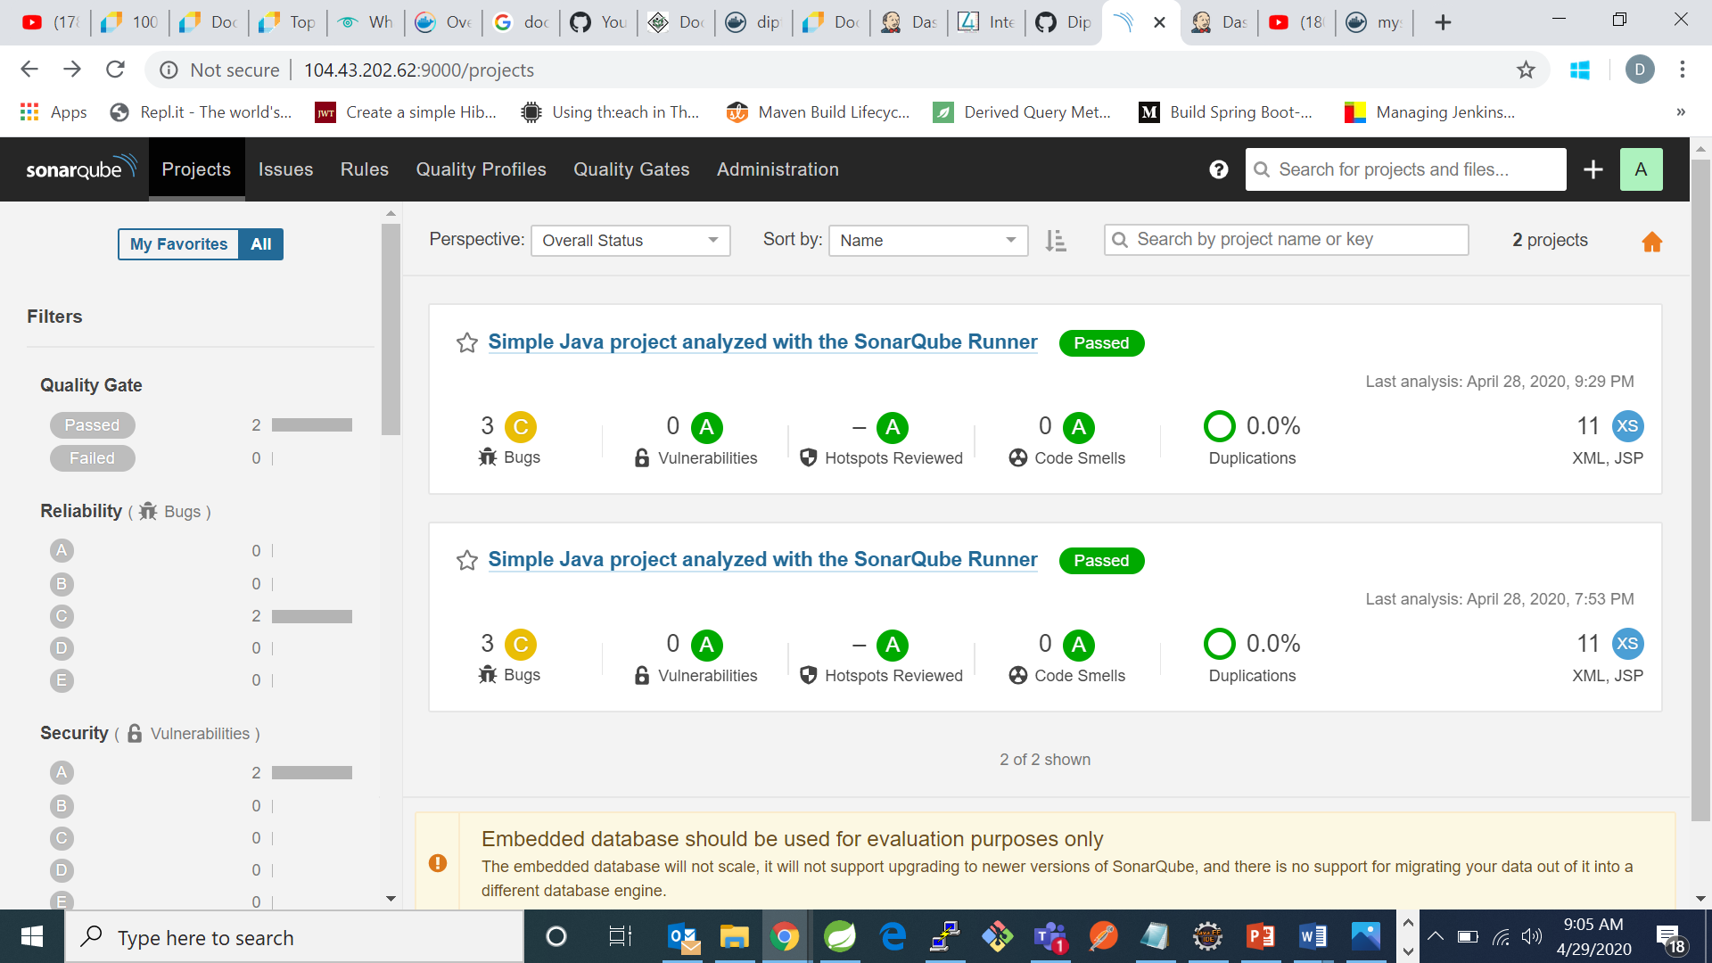

In this the first one is my code analysis.

The three bugs in my code can be seen by going to the issues:

